Low Pass Filter Design

The digital low pass filter to be implemented in the lab was designed using traditional controller design techniques and state space methods. First a second order low pass filter is designed in the analog domain using traditional techniques. The damping ratio ( $ζ)$ and cutoff frequency ( $w_{o}^{2})$ are chosen to be 0.707 and 400π respectively.

$$G\left(s\right)= \frac{w_{o}^{2}}{s^{2}+2ζw_{o}s+ w_{o}^{2}}$$

With these component values chosen it can be seen in Figure 1 that this controller is very stable with both poles far into the open left hand plane and no zeros. However from Figure 2 it can be seen that there is approximately a 53.2O phase lag between the input and output signal and a gain of -0.56 dB. In the lab is it required that the input and output signals are in phase with unity gain. Therefore it is required to design a third order controller.

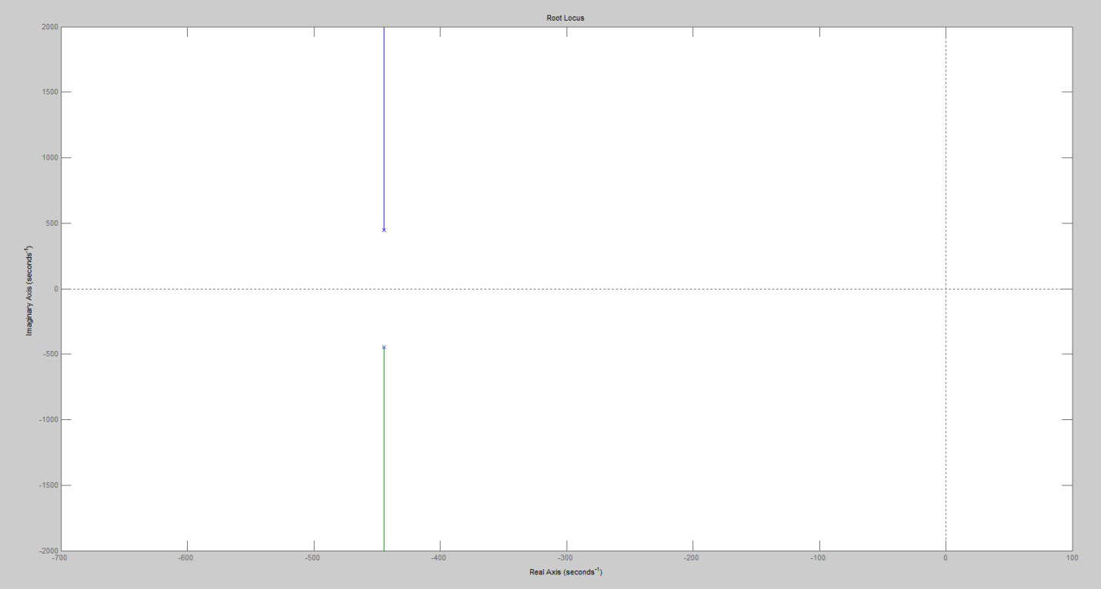

Figure 1. Low Pass Filter Root Locus Plot (Analog)

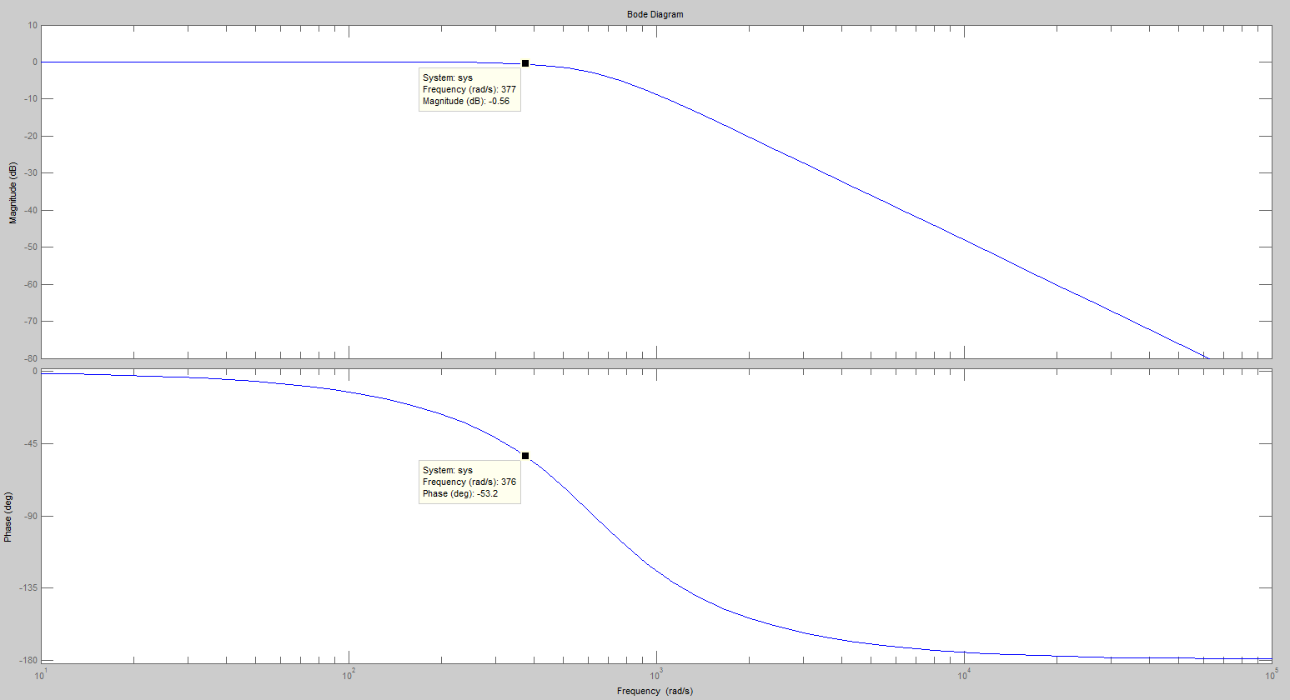

Figure 2. Low Pass Filter Bode Plot (Analog)

The controller will be augmented to with a lead compensator so that the controller takes on the form

$$G\left(s\right)= \frac{K}{\sqrt{a}}\left(\frac{1+aTs}{1+Ts}\right)\left(\frac{w_{o}^{2}}{s^{2}+2ζw_{o}s+ w_{o}^{2}}\right)$$

where

$$a= \frac{1+sin∅_{m}}{1-sin∅_{m}}$$

$$T= \frac{1}{w_{m}\sqrt{a}}$$

The controller will be filtering data at 60 Hz so by setting $w_{m}=120π$, $∅_{m}=53.$ 2O and selecting K such that unity gain is achieved we get a response as shown in Figure 3 and Figure 4. Now we have a stable low pass filter with a cutoff frequency of 200 Hz that provides unity gain and no phase shift at 60 Hz.

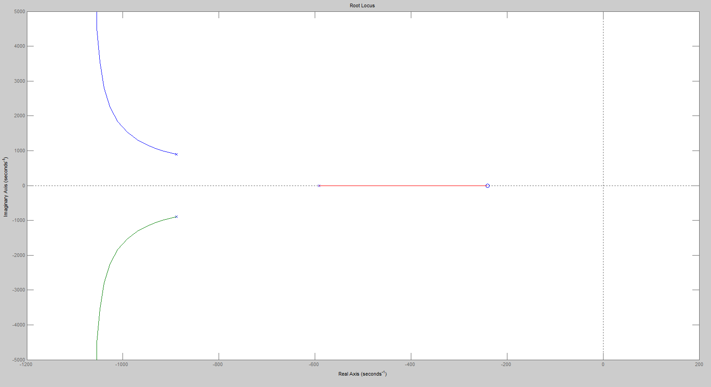

Figure 3. Third Order Low Pass Filter, root locus, Analog

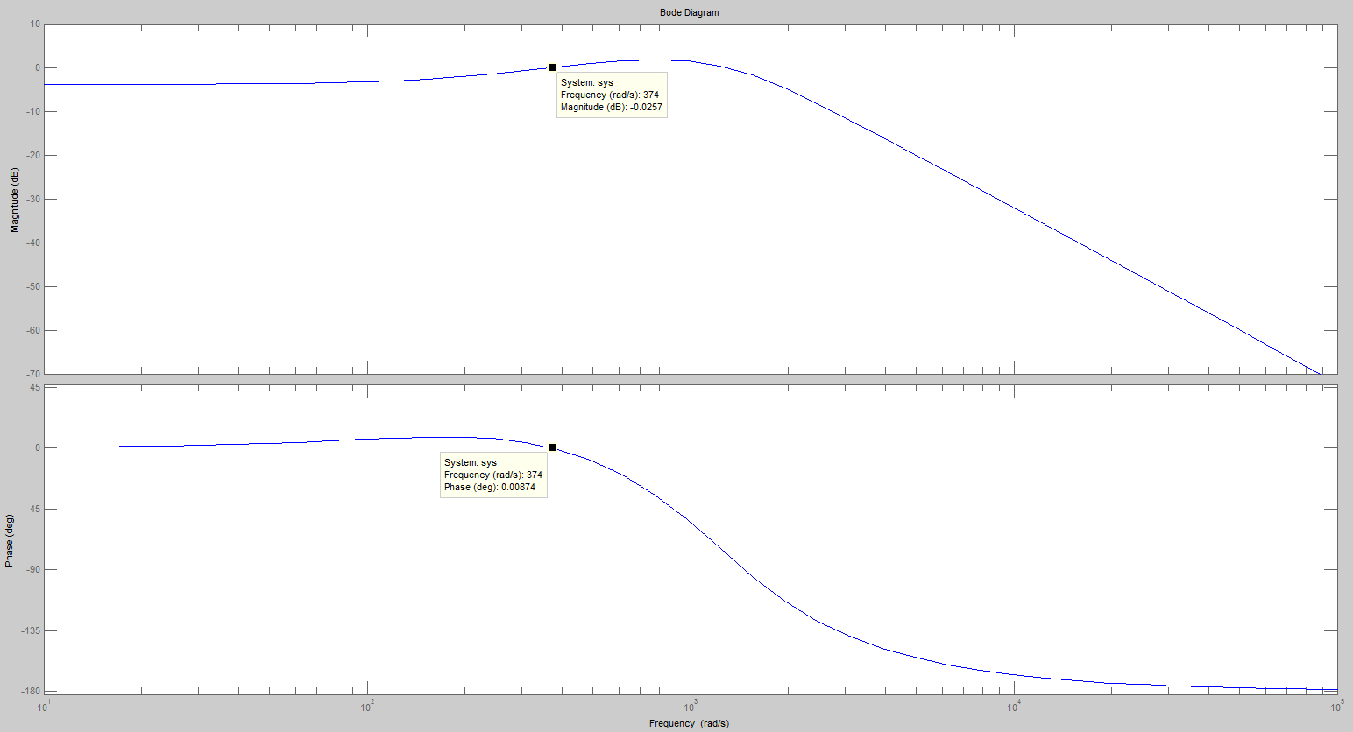

Figure 4. Third Order Low Pass Filter, bode plot, analog

The next step is to convert the filter to a discrete model that can be implemented with a microcontroller. Using the tools provided in matlab the following script was written to quickly calculate the third order filter parameter values.

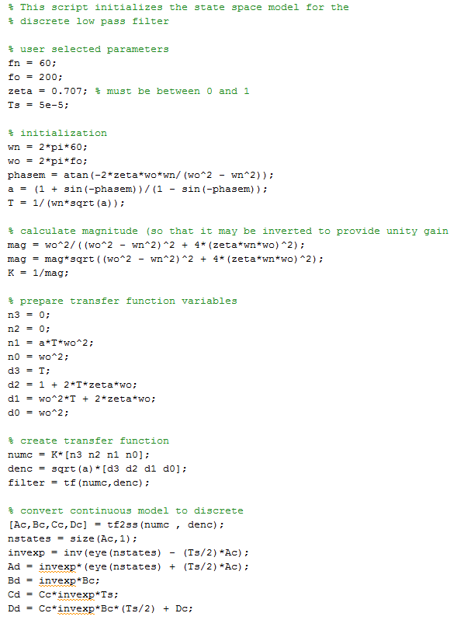

Once the transfer function is designed it is converted to a state space model using the tf2ss() function. Then the continuous state space model is converted to a discrete state space model using the following conversions:

$$A_{d}={\left(I-\frac{T_{s}}{2}A_{c}\right)}^{-1}\left(I+\frac{T_{s}}{2}A_{c}\right)$$

$$B_{d}={\left(I-\frac{T_{s}}{2}A_{c}\right)}^{-1}B_{c}$$

$$C_{d}=C_{c}{\left(I-\frac{T_{s}}{2}A_{c}\right)}^{-1}T_{s}$$

$$D_{d}=C_{c}{\left(I-\frac{T_{s}}{2}A_{c}\right)}^{-1}B_{c}\left(\frac{T_{s}}{2}\right)+D_{c}$$

This results in the following discrete state space parameters:

$$A_{d}=\left[\begin{matrix}0.8852 & -125.0779 & -4.4036E-3 \\ 4.7131E-3 & 0.9969 & -1.1009 \\ 1.1783E-9 & 4.9922E-5 & 1.0000\end{matrix}\right]$$

$$B_{d}=\left[\begin{matrix}0.9426 \\ 2.3566E-5 \\ 5.8914E-10\end{matrix}\right]$$

$$C_{d}=\left[\begin{matrix}0.0029 & 124.9691 & 2.9817E-4\end{matrix}\right]$$

$$D_{d}=\left[0.0015\right]$$

Based on these parameters the output of the filter $y\left[n\right]$ can be calculated based on the input $u\left[n\right]$ at each sampled period of 50 µs according to the state space relationship below.

$$x\left[n+1\right]=A_{d}x\left[n\right]+ B_{d}u\left[n\right]$$

$$y\left[n\right]=C_{d}x\left[n\right]+ D_{d}u\left[n\right]$$

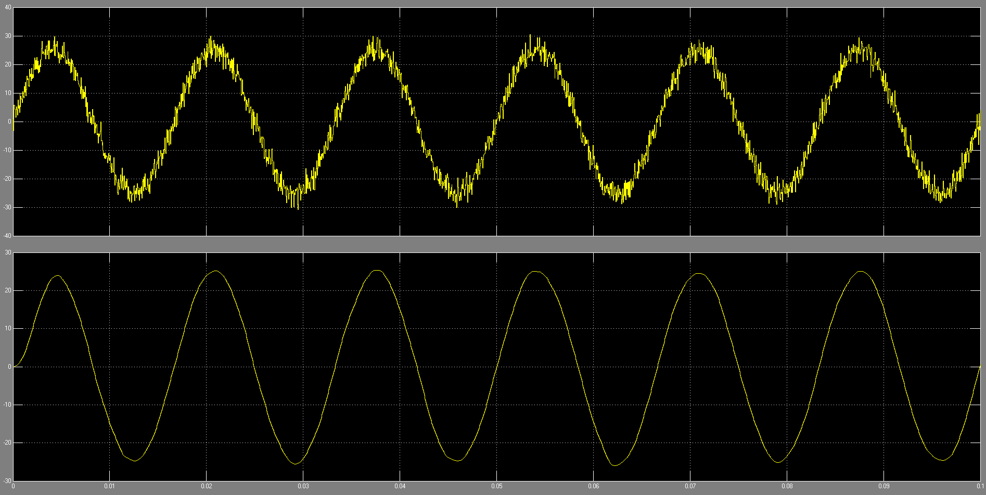

Figure 5. Sample of Digital Filter